# Project Design Phase-I Solution Architecture

|  |  |
| --- | --- |
| Mentor Name | T Sivalingam |
| Team ID | PNT2022TMID33576 |
| Project Name | IOT – Smart Waste Management System |
| Maximum Marks | 4 Marks |

**Solution Architecture:**

Solution architecture is a complex process – with many sub-processes – that bridges the gap between environmental problems and technology solutions. Its goals are to:

* Find the best tech solution to solve existing business problems.
* The proposed system would be able to automate the solid waste monitoring process and management of the overall collection process using IOT.
* In this system, whenever the waste bin gets filled this is acknowledged by placing the circuit at the waste bin, which transmits it to the receiver at the desired place in the area or spot.
* The received signal indicates the waste bin status at the monitoring and controlling system.

# Example - Solution Architecture Diagram:

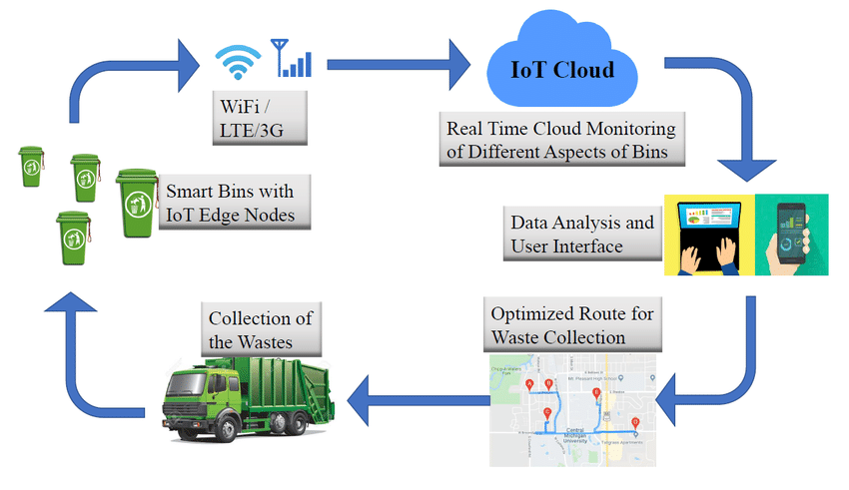

*Figure 1: Architecture and data flow of the smart waste management system*

**Reference:** [**https://www.researchgate.net/figure/The-proposed-system-architecture_fig2_341900743**](https://www.researchgate.net/figure/The-proposed-system-architecture_fig2_341900743)